The Entity-Relationship Model:

The entity-relationship (E-R) data model was developed to facilitate database design by allowing specification of an enterprise schema that represents the overall logical structure of a database. The E-R model is very useful in mapping the meanings and interactions of real-world enterprises onto a conceptual schema. The E-R data model employs three basic concepts: entity sets, relationship sets, and attributes, which we will study first. The E-R model also has an associated diagrammatic representation, the E-R diagram, which is discussed later.

Entity Types, Entity Sets, Attributes, and Keys

- Entities:

The basic object that the ER model represents is an entity, which is a thing in the real world with an independent existence. An entity may be an object with a physical existence (for example, a particular person, car, house, or employee) or it may be an object with a conceptual existence (for instance, a company, a job, or a university course).

- Attributes:

Each entity has attributes—the particular properties that describe it. For example, an EMPLOYEE entity may be described by the employee’s name, age, address, salary, and job. For each attribute, there is a set of permitted values, called the domain, or value set, of that attribute. The domain of attribute course_id might be the set of all text strings of a certain length. Similarly, the domain of attribute salary of an employee might be a numeric value.

- Composite versus Simple (Atomic) Attributes:
Composite attributes can be divided into smaller subparts, which represent more basic attributes with independent meanings. For example, an attribute name could be structured as a composite attribute consisting of first_name, middle_initial, and last_name. Similarly an address can be divided into the Attributes Street, city, state, and zip code as shown in Figure1.

Figure 1 Composite Attributes

Attributes that are not divisible are called simple or atomic attributes.

- Single-Valued versus Multivalued Attributes.
Most attributes have a single value for a particular entity; such attributes are called single-valued. For example, Age is a single-valued attribute of a person. In some cases an attribute can have a set of values for the same entity—for instance, a Colors attribute for a car, or a College_degrees attribute for a person. Cars with one color have a single value, whereas two-tone cars have two color values. Similarly, one person may not have a college degree, another person may have one, and a third person may have two or more degrees; therefore, different people can have different numbers of values for the College_degrees attribute. Such attributes are called multivalued. A multivalued attribute may have lower and upper bounds to const rain the number of values allowed for each individual entity. For example, the Colors attribute of a car may be restricted to have between one and three values, if we assume that a car can have three colors at most.

- Stored versus Derived Attributes.
In some cases, two (or more) attribute values are related—for example, the Age and Birth_date attributes of a person. For a particular person entity, the value of Age can be determined from the current (today’s) date and the value of that person’s Birth_date. The Age attribute is hence called a derived attribute and is said to be derivable from the Birth_date attribute, which is called a stored attribute. Some attribute values can be derived from related entities; for example, an attribute Number_of_employees of a DEPARTMENT entity can be derived by counting the number of employees related to (working for) that department.

- NULL Values.
In some cases, a particular entity may not have an applicable value for an attribute. For example, the Apartment_number attribute of an address applies only to addresses that are in apartment buildings and not to other types of residences, such as single-family homes. Similarly, a College_degrees attribute applies only to people with college degrees. For such situations, a special value called NULL is created. An address of a single-family home would have NULL for its Apartment_number attribute, and a person with no college degree would have NULL for College_degrees. NULL can also be used if we do not know the value of an attribute for a particular entity—for example, if we do not know the home phone number of ‘John Smith’.The meaning of the former type of NULL is not applicable, whereas the meaning of the latter is unknown. The unknown category of NULL can be further classified into two cases. The first case arises when it is known that the attribute value exists but is missing—for instance, if the Height attribute of a person is listed as NULL. The second case arises when it is not known whether the attribute value exists—for example, if the Home_phone attribute of a person is NULL.

Key Attributes of an Entity Type:

An important constraint on the entities of an entity type is the key or uniqueness constraint on attributes. An entity type usually has one or more attributes whose values are distinct for each individual entity in the entity set. Such an attribute is called a key attribute, and its values can be used to identify each entity uniquely. For example, stu_id is a key in the Student relation (table). In ER diagrammatic notation, each key attribute has its name underlined inside the oval,

Relationship Sets:

A relationship is an association among several entities. For example, we can define a relationship advisor that associates instructor Katz with student Shankar. This relationship specifies that Katz is an advisor to student Shankar as shown in figure 2.

A relationship set is a set of relationships of the same type. Formally, it is a mathematical relation on n ≥ 2 entity sets. If E1, E2, . . . , En are entity sets, then a relationship set R is a subset of {(e1, e2, . . . , en) | e1 $ϵ$ E1, e2 $ϵ$ E2, . . . , en $ϵ$ En}, where (e1, e2, . . . , en) is a relationship.

Example: Consider a relationship type WORKS_FOR between the two entity types EMPLOYEE and DEPARTMENT, which associates each employee with the department for which the employee works in the corresponding entity set. Each relationship instance in the relationship set WORKS_FOR associates one EMPLOYEE entity and one DEPARTMENT entity.

Figure 2 Relationship set Advisor
Mapping Cardinalities:

Mapping cardinalities, or cardinality ratios, express the number of entities to which another entity can be associated via a relationship set. Mapping cardinalities are most useful in describing binary relationship sets, although they can contribute to the description of relationship sets that involve more than two entity sets.

For a binary relationship set R between entity sets A and B, the mapping cardinality must be one of the following:

• One-to-One. An entity in A is associated with at most one entity in B, and an entity in B is associated with at most one entity in A. (See Figure 3(a))
Examples: 1. Manager – Department (one manager can mange at most one department and one department can be managed by at most one manager only)
2. Employee – Medical Policy / Company Car

• One-to-Many. An entity in A is associated with any number (zero or more) of entities in B. An entity in B, however, can be associated with at most one entity in A. (See Figure 3(b))

Examples:
- Department – Employee (one department can have many employees but one employee can have at most one department)
- Train – Passenger
- Supervisor – Employee
- Advisor – Student
- Customer – Account
- Bank – Branch
- Author – Book
- Employee - Dependent

Figure 3 Mapping Cardinalities (a) one –to-one (b) One-to-many
Figure 4 Mapping Cardinalities (a) Many–to-one (b) Many-to-many

• Many-to-One. An entity in A is associated with at most one entity in B. An entity in B, however, can be associated with any number (zero or more) of entities in A. (See Figure 4(a))

Examples:
- Employee – Department (One employee is associated with at most one department whereas one department can have many employees)
- Passenger – Train
- Employee – Supervisor
- Student – Advisor
- Account – Customer
- Branch – Bank
- Book – Author
- Dependent - Employee

• Many-to-Many. An entity in A is associated with any number (zero or more) of entities in B, and an entity in B is associated with any number (zero or more) of entities in A. (See Figure 4(b))

Examples:
- Teacher - Course (One teacher can teach more than one courses and one particular course can be taught by more than one teachers)
- Employee – Project
- Product – Supplier
- Product – Salesman
- Student - Course

Recursive Relationships:
Recursive relationships occur within unary relationships. ( same entity set) The relationship may be one to one, one- to- many or many- to- many. That is the cardinality of the relationship is unary. The connectivity may be 1:1, 1: M, or M: N.
For example:
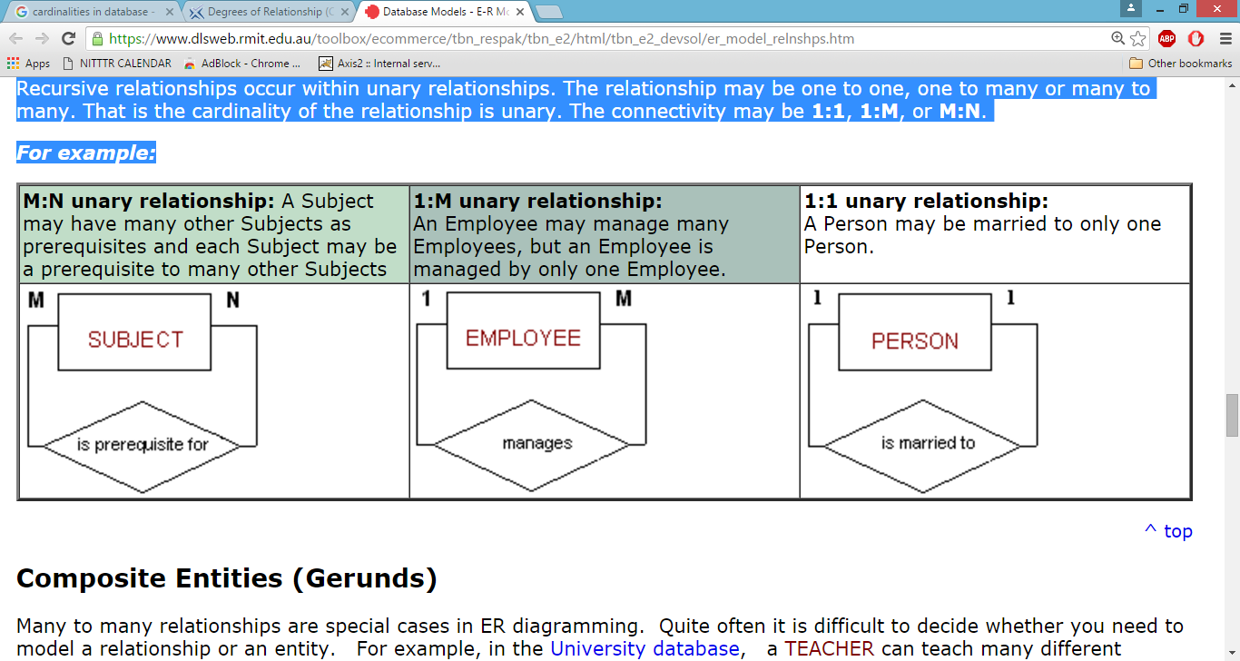

Figure 5 Recursive Relationship
Source: https://www.dlsweb.rmit.edu.au/toolbox/ecommerce/tbn_respak/tbn_e2/html/tbn_e2_devsol/er_model_relnshps.htm

Participation Constraints:

The participation of an entity set E in a relationship set R is said to be total if every entity in E participates in at least one relationship in R. If only some entities in E participate in relationships in R, the participation of entity set E in relationship R is said to be partial. In Figure 3(a), the participation of B in the relationship set is total while the participation of A in the relationship set is partial. In Figure 3(b), the participation of both A and B in the relationship set are total.

Example: We expect every student entity to be related to at least one instructor through the advisor relationship. Therefore the participation of student in the relationship set advisor is total. In contrast, an instructor need not advise any students. Hence, it is possible that only some of the instructor entities are related to the student entity set through the advisor relationship, and the participation of instructor in the advisor relationship set is therefore partial.
E-R Diagram Symbols

Figure 6 E-R Diagram Symbols

E-R Diagram Examples

A College Database Application: Here we are going to design an Entity Relationship (ER) model for a college database . Say we have the following statements.
- A college contains many departments
- Each department can offer any number of courses
- Many instructors can work in a department
- An instructor can work only in one department
- For each department there is a Head
- An instructor can be head of only one department
- Each instructor can take any number of courses
- A course can be taken by only one instructor
- A student can enroll for any number of courses
- Each course can have any number of students

Step 1: Identify the Entities
What are the entities here? From the statements given, the entities are:
- Department
- Course
- Instructor
- Student

Stem 2: Identify the relationships
- One department offers many courses. But one particular course can be offered by only one department. hence the cardinality between department and course is One to Many (1:N)
- One department has multiple instructors . But instructor belongs to only one department. Hence the cardinality between department and instructor is One to Many (1:N)
- One department has only one head and one head can be the head of only one department. Hence the cardinality is one to one. (1:1)
- One course can be enrolled by many students and one student can enroll for many courses. Hence the cardinality between course and student is Many to Many (M:N)
- One course is taught by only one instructor. But one instructor teaches many courses. Hence the cardinality between course and instructor is Many to One (N :1)

Step 3: Identify the key attributes
- "Department_Name" can identify a department uniquely. Hence Department_Name is the key attribute for the Entity "Department".
- Course_ID is the key attribute for "Course" Entity.
- Student_ID is the key attribute for "Student" Entity.
- Instructor_ID is the key attribute for "Instructor" Entity.

Step 4: Identify other relevant attributes
- For the department entity, other attributes are location
- For course entity, other attributes are course_name,duration
- For instructor entity, other attributes are first_name, last_name, phone
- For student entity, first_name, last_name, phone

Step 5: Draw complete ER diagram
By connecting all these details, we can now draw ER diagram as given below.

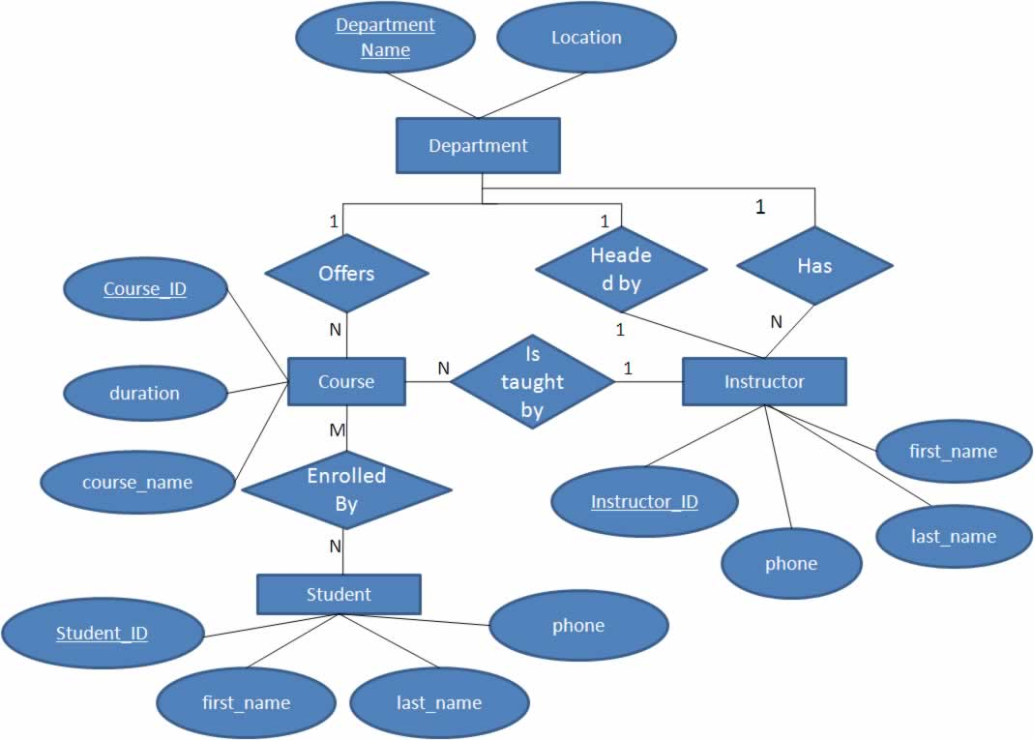

Figure 7 E-R Diagram for the COLLEGE database
A Company Database Application
The COMPANY database keeps track of a company’s employees, departments, and projects.Suppose that after the requirements collection and analysis phase, the database designers provide the following description of the miniworld—the part of the company that will be represented in the database:

- The company is organized into departments. Each department has a unique name, a unique number, and a particular employee who manages the department. We keep track of the start date when that employee began managing the department. A department may have several locations.
- A department controls a number of projects, each of which has a unique name, a unique number, and a single location.
- We store each employee’s name, Social Security number,2 address, salary, sex (gender), and birth date. An employee is assigned to one department, but may work on several projects, which are not necessarily controlled by the same department. We keep track of the current number of hours per week that an employee works on each project. We also keep track of the direct supervisor of each employee (who is another employee).
- We want to keep track of the dependents of each employee for insurance purposes. We keep each dependent’s first name, sex, birth date, and relationship to the employee.
Figure 8 shows how the schema for this database application can be displayed by means of the graphical notation known as ER diagrams.

Figure 8 E-R Diagram for the COMPANY database

References:
  - Database System Concepts 6e By Abraham Silberschatz, Henry Korth and S Sudarshan
  - Fundamentals of Database Systems 6e By Elmsari Navathe

